2009 Amherst summer science program
July 26 – August 15 at Amherst College
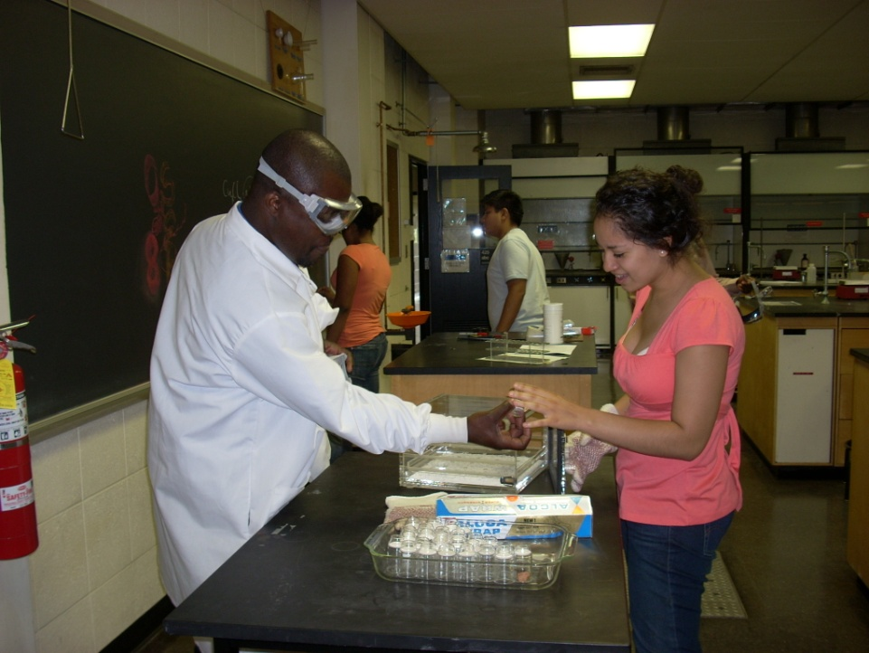  Program Description  Three Weeks. The Amherst Summer Science Program offers three weeks of Amherst-level math and science.  Math. Students have daily calculus classes for all three weeks, including homework and exams.  Prof. Greg Call, Dean of Faculty  Prof. Rob Benedetto  Science. Each week features a different science course: Physiology, Chemistry, and Psychology.  Prof. Pat O’Hara  Dr. Richmond Ampiah-Bonney  Prof. Catherine Sanderson  Writing. In addition to a week-long writing seminar with Prof. Jyl Gentzler, we will have workshops and speakers with staff from the Amherst College Writing Center.  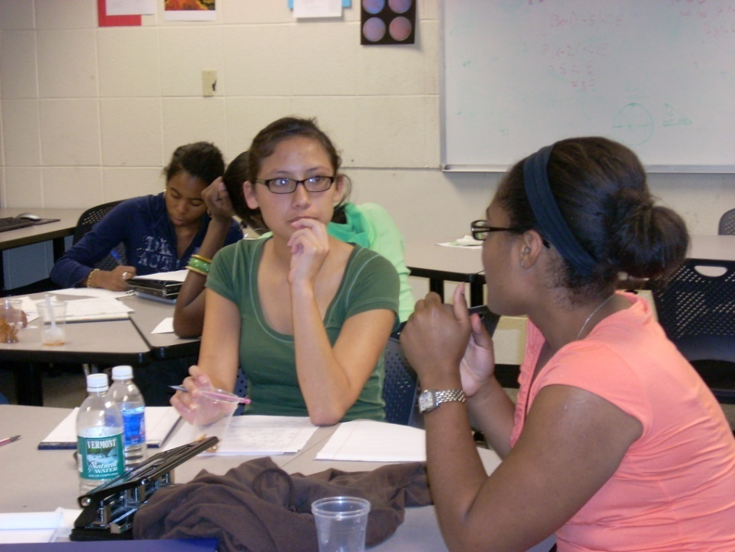  Should you consider Summer Science?  SSP is aimed at incoming with a strong interest in science, math or premedical study to motivate them to spend part of their summer in class. First priority (in general) will be given to students with weaker calculus or science preparation.  Typical SSP students are:  - premedical students who want to get a sense of how demanding the science and calculus requirements are,  - students concerned about how they perform on high-stakes math and science exams,  - students who attended high schools with uneven quality or requirements in science and math courses. | Summer Science Offers:  - A three-week introduction to Amherst calculus, science classes and laboratories  - An opportunity to get to know faculty with small classes and accessible office hours  - Advising for premedical, math and science  - An introduction to many of Amherst’s academic resources  - Research and internship information, and a chance to talk to current science majors  - A chance to make friends and meet the classmates who will share your fall courses  Participation in the SSP is by invitation. Amherst College pays for travel, room and board, and program expenses. Students receive a $1000 credit to replace earnings expectations in their freshman year.  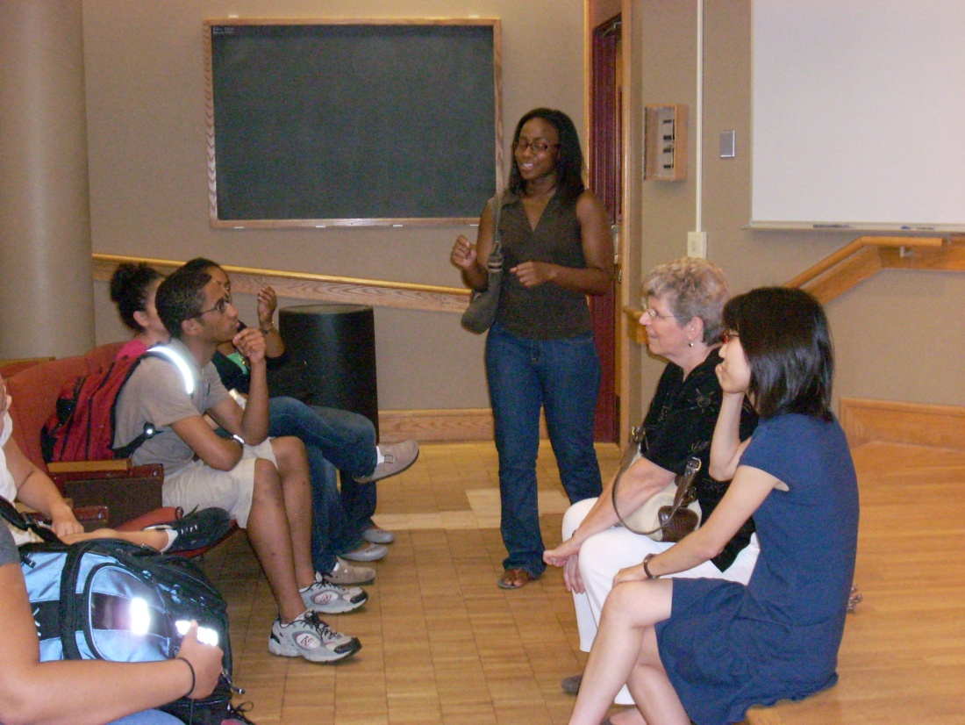  Information and Advising. Sessions with college deans, current students and faculty will provide information on course selection, pre-medical and science requirements and opportunities.  Academic Resources. SSP student tutors live and work with the summer science students, and offer help during the evening study hall. Faculty are available during office hours; additional tutors and the director of the Moss Quantitative Center work closely with students.  Camaraderie and Exploration. SSP isn’t all study and advising. Students have the opportunity to make new friends and explore the Amherst area.  Getting to Amherst  AC site with links on:  - How to get to campus  - Parking  Who'll be there: the current list of participants for 2009.

